Subject : DSE(Computer Applications) Cyber Forensics

Practical 2
- Study of Network-Related Commands (Linux)
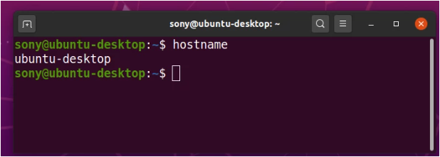
  - Hostname : Shows computer’s hostname.

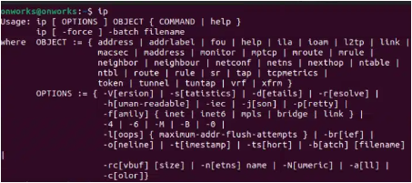

  - ip(earlier used as ipconfig) : Used to view and configure network interfaces
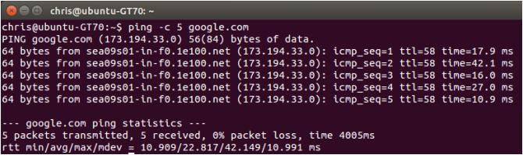
  - ping : Used to test connectivity to another host.
- Shows:
  - Packet loss
  - Round-trip time
  - Whether network is up or down
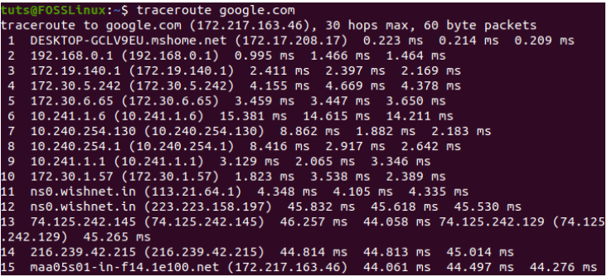
  - Traceroute :
                - Shows the path packets take to reach a destination.
                - Helps identify where network delay or failure occurs.
                - Displays each hop’s IP and response time.
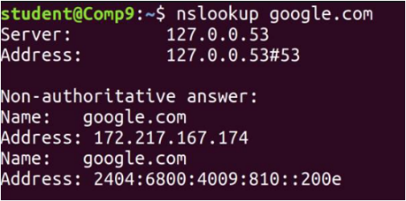
  - nslookup : used to query DNS servers to find the IP address of a domain or the domain name of an IP.

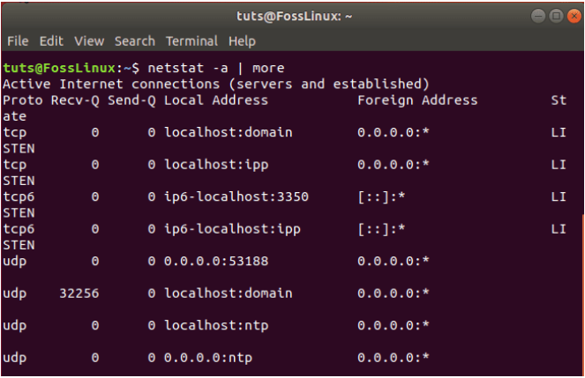
  - netstat(now used as ss) :
- Displays network connections, routing tables, ports, etc.
- Here, netstat -a : Show all active connections

